CHAPTER I

INTRODUCTION

*Background of the Study*

In today’s technologically demanding and fast changing world, the challenge every business and institution face is how to make things efficient, fast, and effective.

The use of computer-based technology increases productivity and efficiency in data processing, thus minimizing, if not totally eliminating the use of the manual process in most business transactions. The computer-based business solution simultaneously tracks sales activity and inventory, making data more available for analysis to increase revenue and minimize loss.

On top of this, automating the transaction and inventory system allows things to run through a network making information and resource sharing a lot faster, efficient, and more secure.

The developement of the Transaction and Inventory System provides quality of services for the Bookstore of St. Anthony’s College which caters to all the needs of each department/unit in terms of school supplies, computer supplies, sale materials, souvenirs, and other materials and equipments needed by the institution. Every department or unit requests from the bookstore if they run out of supplies that they need for the everyday operations of the office. The department or unit secretary fill up the requisition form from the bookstore and is given to the dean or office head for approval. The Bookstore staff then provides the corresponding prices per requested supply and the requisition slip is forwarded to the Budget In-charge for budgeting. The items are then claimed in the Bookstore. The same process is also applied to the students, parents, or guardian for requisition and the amount is paid to the cashier. They will then present the receipt in the Bookstore to claim the items.

At present, the property management procurement supervisor is supervising the SAC Bookstore. The organizational structure is presented in Figure 1.

PROPERTY MANAGEMENT PROCUREMENT SUPERVISOR

PROPERTY ACCOUNTABILITY

BOOKSTORE STAFF

STUDENTS AND PARENTS/GUARDIAN

HEAD, FACULTY AND STAFF

Figure 1. Bookstore Organizational Chart

In the organizational chart shown in Figure 1, the Property Management Procurement Supervisor is the one who will assist the developer on how the project would be implemented in the school and will also provide or help the developers with all the information needed in the project.

The Bookstore staff will facilitate the requirements and needs of the bookstore and will update the information in the said office depending on the resources given by the Property Management Procurement Supervisor.

The SAC Bookstore is currently using a manual process for transacting item requests, sales, and inventory. The process starts with filling up a requisition form as shown in Figure 2 for the requested items by the department or office. The Bookstore staff in-charge fills out the amount of requested items and the total price on the requisition form. Then, the request is sent back for the approval of the department or office head and budgeting by the Budget In-charge before the item can be checked out from the bookstore.

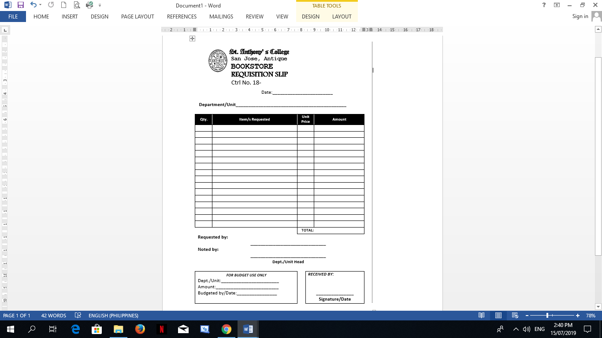

Figure 2. Requisition Form

After an item is requested, the stock card which is usually a spreadsheet program, is updated as shown in Figure 3, then consolidated and entered into the general journal.

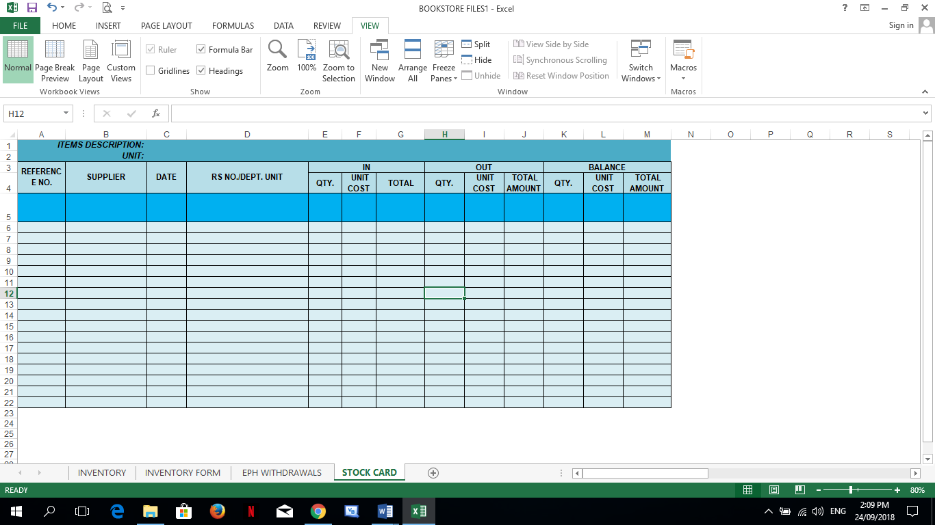

Figure 3. Stock Card

After the request of items are approval and delivered, the summary of withdrawals for the month is reported as shown in Figure 4.

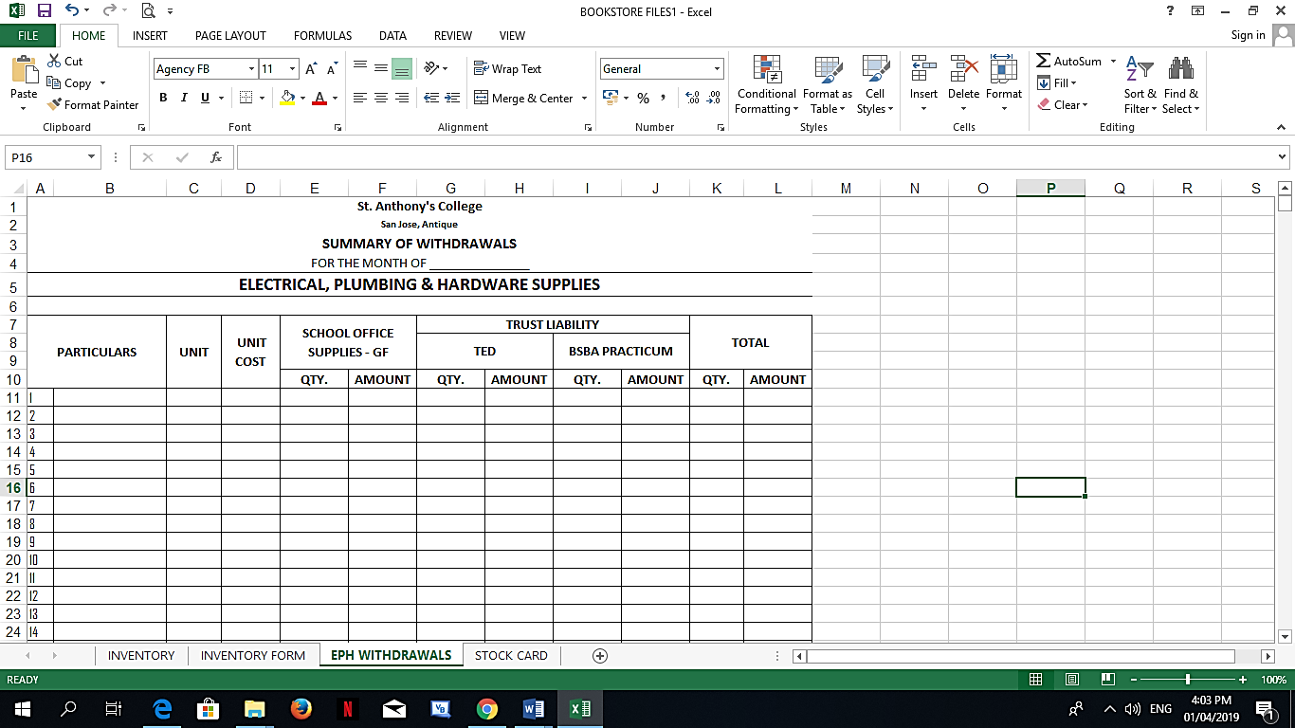

Figure 4. Summary of Withdrawals

Then, a Bookstore staff would conduct an inventory count of the item or equipment and tie-up the record with actual counts on the record in the inventory form as shown in Figure 5.

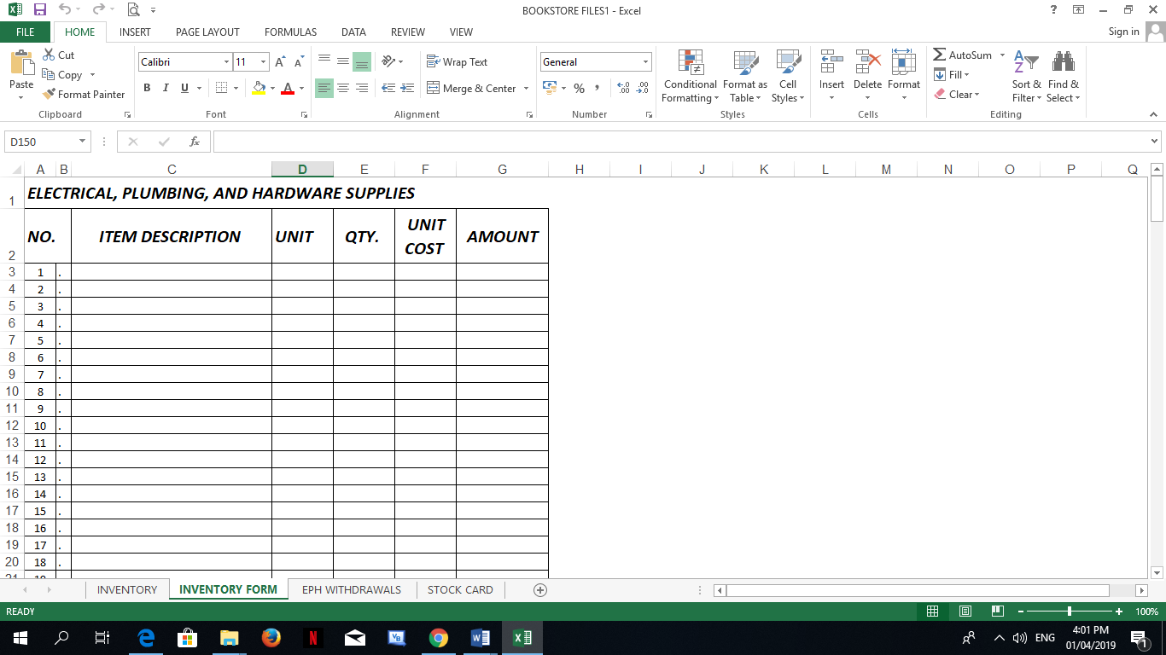

Figure 5. Inventory Form

St. Anthony’s College Bookstore is responsible for the transaction and inventory of general stocks, electrical items, and equipments. Furthermore, the SAC Bookstore faces the problem of manually inputting the data in the master list. Thus, it is difficult to identify the availability of the stocks. This results to not identifying the wrong or damaged items released, difficulty in determining items that need to be re-ordered, and backlogs in submitting reports.

The manual process is tedious, slow and redundant. Therefore, there is a need to develop a transaction and inventory system to automate the process and help with data analysis for future acquisition of electrical items and equipments.

With this in mind, this study aims to design, develop, and implement a system entitled “Transaction and Inventory System of Electrical Supplies and Equipment of St. Anthony’s College”. The system aims to automate the current manual transaction and inventory of the bookstore and assist the staff in generating sales and inventory reports with more accuracy and efficiency, thus allowing effective decision-making for budgeting by the administrators.

*Objectives of the Study*

*General Objective:*

To design, develop, and test the Transaction and Inventory System of St. Anthony’s College, San Jose de Buenavista, Antique.

Specific Objectives:

1. To design an automated transaction and inventory system that can determine the items that have reached its re-order point.
2. To develop a network-based system that can handle the item request transaction of each department and office.
3. To develop a normalized database to eliminate data redundancy.
4. To test the system for the implementation at St. Anthony’s College that would automate the existing process, generate and analyze data from sales and transactions to aid in decision-making for future acquisitions.

Significance of the Study

This study is significant and beneficial to the following:

*Departments and offices of the College.* This study is beneficial for departments and offices of the College since requisition forms are easier to access through network basis.

*The Administrators.* This study is beneficial for the administrators who also play an important role in the execution of the system that provide approvals to be sent to the bookstore via the network and will be received as a pop up message alert.

*The Bookstore staff.* This study is beneficial for the bookstore staff since access of data and generating daily and monthly inventory reports are made easier. The system will also provide the list of items that have reached its re-order point.

*The students and parents.* This study is beneficial for students and parents since the transaction will be made easier for them and they can avoid the usual long queues of customers in the Bookstore.

Scope and Limitations

This study entitled “Transaction & Inventory System of St. Anthony’s College” mainly focuses on the development of the Bookstore’s Transaction and Inventory of items, supplies, and equipments needed by the institution.

This system will handle security that includes user accounts that contains the functions for adding, and editing user names and passwords. Of course, the authorized user can be the only one who can utilize the system.

The system will implement a file maintenance module that will handle the files, records, and important data specifically, the products that contains all the records of adding of items.

The system will provide a generation of reports which are necessary in proper evaluation of transaction and inventory records such as withdrawal reports and daily and monthly inventory, including the summary report. A pop-up message warns the staff as each item reaches the re-order point and this will provide the list of items to be ordered and product maintenance. The stock ledger card monitors the in (purchases) and out (withdrawal) of items.

Only authorized persons can access the retail database. However, cashiering is not included in the system.

CHAPTER II

REVIEW OF RELATED LITERATURE

Computer-based system is a complex system wherein information technology plays a major role. It makes the work easier, faster, and more accurate. Due to that fact, the automated scheme has become essential to small and big companies for they are expected to give the best services possible. Nevertheless, some businesses still prefer sticking with the system that is not integrated with technology. Some probable causes are computer illiterate staff and lack of funds. Companies, especially the big ones, are recommended to switch from manual to automated systems because this will improve the efficiency and productivity of the business which will uplift the industry’s reputation.

One of the most sought after automated systems of different companies is a Transaction and Inventory System which comes hand in hand. A Transaction and Inventory System is very important in every organization because a good sales and inventory management can create excellent productivity.

Most of the retailing market is using the traditional way in the inventory management system where a person is assigned to check and record the stock by hand using pen and paper. This is where operations with regards to all the stock are achieved. It is without a doubt that one of the major roles played by today in almost every area in society particularly in business and marketing is the computerized system.

This Transaction and Inventory System of Electrical Supplies and Equipments of St. Anthony’s College enables us to make a very detailed work and follows accurate directives without error. The reviewed literatures in connection with this study helped demonstrate the objectives of the system to make the process fast and well-organized, which means that they can process much more quickly than humans.

*Equipment Inventory Management and Transaction Recording Using Bar Coding Scheme via VB6*

Engineering is considered as one of the vital fields for economic and technological modernization in every country. Engineering tackles not only on modernization of buildings, bridges, and constructions but also through the Information Communication Technology. Modernization in ICT encompasses the development of methodologies to pave way for ease in every transaction that is made in a given office. With modernization tracks, management therefore would be aligned to paperless and faster transactions. This study had been developed to contribute towards development of equipment management and transaction recordings.

The paradigm incorporated observation of the existing Laboratory Transaction Recording and Equipment Inventory Monitoring. After a thorough observation and analysis, a new system to improve transaction recording would be designed and recommended; as such, AutoLab would be suggested. Auto Lab is a coined term meaning Automated Laboratory. The generation of AutoLab was through the Visual Basic System and Microsoft Access to attain a well-developed AutoLab system. Visual Basic was used for program processes while the Microsoft Access was used for the different databases designed for the system. The AutoLab system had undergone several experiments to test the effectivity of the system. Evaluation was done through a survey to assess the acceptability of the system to the ECE community.

The method of research used was a Quasi Experimental method as it utilized both experimental and descriptive method. Experimental because the system will be subjected to a series of experiments to test its accuracy, efficiency, effectiveness, and reliability. The researcher used experimentations to test the proposed system automation through the actual test implementations. Two main experiments have been conducted - the test for accuracy of the system in transaction recording and the equipment inventory monitoring. The test for accuracy was divided into four parts, namely: (1) Borrowing of Key; (2) Borrowing of Equipments; (3) Returning of Keys; and (4) Returning of Equipments. On the other hand, the equipment inventory monitoring incorporates the analysis of the equipment utilization in terms of what equipments were usually borrowed, in what subjects a certain equipment is being used, and the history of usage for a given equipment.

AutoLab is a coined term for Automated Laboratory. The system aimed to develop the transactions recordings and inventory reports under the ECE Laboratory automated utilizing the existing PUP Student Identification Card to supplement information regarding a student borrower. Autolab System Transaction Flow is the process on how the system would work all throughout. The Bar Code in a PUP student identification card is scanned and read through a bar code reader. It sends the scanned code for verification wherein it would automatically present the student number, student name, year, and section. With automatic time updating, the time that the room key bar code is scanned, automatically logs the time borrowed and returned to the transactions recording.

The borrowing of equipment undergoes the same process. The equipment bar code would be scanned and automatically register the equipment borrowed under the name of the borrower. The time of release would be entered and recorded in the system. The Bar Code for equipments was generated and coded in relation to the PUP Property Number in a Code 128 Format. As the Identification Card of the student is scanned, the system retrieves the information of the user and displays such information to the Graphical User Interface (GUI). When a key bar code is scanned, the system filters and presents the room utilization schedule. The system is synchronized with the time embedded in the computer unit used - signifying that when a transaction is being saved, it automatically logs in the time of a key being borrowed and automatically logs out when returned. During the equipment transaction, when an equipment is being borrowed and scanned, the subject box in the GUI must be filled out through the generated subject bar codes. This is to monitor the subject where the equipment would be utilized. When the save button is clicked, the information is automatically sent to the system for entry log of the time borrowed or returned. In the experimentation made in returning keys and equipments, the record was seen to be complete and accurate in terms of time logs during the returning process. The record was seen to be complete and automatically log the time the key or an equipment had been returned.

The AutoLab is equipped with four (4) significant databases needed for the system to work out. The first one is the class list which presents the record of ECE students from first year to fifth year – sections one to five. The second database is the Class Schedule where each section of each year level can be checked with regards to their whereabouts during the current semester. The third database is the Room Schedules which present the utilization of each ECE room from Mondays through Saturdays, 7:30 am to 9:00 pm. The last database incorporated the equipments under the ECE Laboratory which include the property number and the status of the equipment. The Log-in Graphical User Interface is allocated for the Admin (the Laboratory Head) and the Student Assistants. This is implemented so that only the permitted personnel of the ECE Laboratory could operate the system (Retrieved March 19, 2019 from https://www.ijera.com/papers/Vol6_issue6/Part%20-%203/P06060392095.pdf).

*Multifunctional Barcode Inventory System for Retailing. Are You Ready for It?*

Inventory management is very important in every organization because a good inventory management can create optimal productivity and lower waste. Basically, inventory management work consists of input, output, and refill. Input is a process of buying new products into the inventory and replacing the old products with the new ones. Meanwhile, output is a procedure of taking out the products from the inventory for sales or usage. Refill is a process of increasing the number of existing products in the inventory in order to fulfill the insufficient products or escalating demands. Most of the retailing market is using the traditional way in the inventory management system where a person is assigned to check and record the stocks by hand using pen and paper. This technique is time-consuming and unavailable for 24/7 especially when the number of stocks in the inventory is large and various in kinds. In addition, it is also a waste of money in hiring manpower to do stock checking and the risks caused by careless mistakes done by the staff may occur. Furthermore, when the entire inventory ordering has to be made manually, it will consume time to contact suppliers and normally the process of ordering is only arranged after the stock is found out empty. Consequently, it will cause a sluggish stock refilling and bring negative effects towards productivity. Having a good inventory management system is never achieved without the computer. Therefore, our project goal is to develop a multifunctional system that will facilitate retail market in managing their inventory and stock ordering effectively and efficiency. The development of the Multifunctional Barcode Inventory Management System (MBIMS) aims to increase the efficiency in stock data inputting by using a barcode scanner; to provide comfort to the staff in monitoring the availability of inventory with auto-alerting function; and to manage the inventory effectively by sending the order to the supplier automatically when the stock is lacking. The case study is based on the development of Inventory Management System.

MBIMS is primarily developed using Microsoft Visual Web Developer 2008 and the core language of the system is ASP.net with Visual Basic. The database used for the system is Microsoft SQL server 2008 and it can be hosted on any Internet Information Server (IIS) that supports .NET framework 3.5 or any ASP.NET development server. The interface of the system is mainly built from Hypertext Markup Language (HTML) with Cascading Style Sheets (CSS) and some functions of the system are developed from Asynchronous JavaScript and XML (AJAX). The reporting function in this system is developed by using ASP.net report system. Besides that, this system can be deployed in any platform or operating system that only needs to have a web browser and do not require any installation or configuration. It is also accessible from anywhere that has an Internet access and will provide an effective method to improve coordination distribution, storage, and access of project information and data of the production process.

In conceptual data modelling, the attributes of these three entities and their relationships among other entities in MBIMS are graphically represented in Entity-Relationship Diagram (ERD). In this E-RD, it has clearly shown that MBIMS consists of seven entities, which are the Administrator, Staff, Management, Supplier, Inventory, Order, and Inventory Activities.

The implementation stage is the most time consuming phase of the entire System Development Life Cycle (SDLC). A fully proper functioning system should be developed and tested in order to ensure the proposed system fulfill business and design requirements. There are several techniques of implementation such as pilots, gradual implementation, phased implementation, and parallel implementation. MBIMS is developed by employing gradual implementation techniques which involves programming languages and program documentation.

MBIMS has been successfully developed and tested throughout an evaluation framework which consists of evaluation paradigms, evaluation techniques, and evaluation of testing. In evaluation paradigms, usability testing is used to ensure the system accomplished the crucial user requirements. The participants of this testing include 15 staff and 35 third year students from both School of Informatics Science and School of International Business and Finance. Observation is performed towards the participants, where user and system performances are recorded in terms of duration time to complete a task, number of errors made, and the navigation path through the system. For evaluation of testing, a unit testing is conducted which focuses on the functionalities of each feature of the system before proceeding to navigation testing and lastly, integration testing. As a result, the status of the usability testing and system testing that was executed through unit testing, navigation testing, and integration testing have successfully verified that the MBIMS is working properly and fully functioning as planned.

Generally, MBIMS can be divided into 5 main functions. First, a Stock Data inputting wherein the system has an inventory management system which covered input, output, and refill that will work with a barcode. All the barcode input and retrieval of the system is scanned using the barcode scanner. Secondly, Inventory Availability checking wherein the system can show the user the in-house inventory and can check availability of stocks at any time. The system will also be able to record all the input, output, and refill and calculate the stock availability accurately. Thirdly, Stock Inventory Refilling and New Stock Ordering wherein the system has the ordering pages for the user to make the order while observing the inventory. Two types of ordering forms have been prepared for refilling and new stock ordering. All the ordering is submitted to the supplier by e-mail. Fourthly, Automated Alerting and ordering in which the system will be able to alert the user when some stocks are less than the pre-set level. The system also can make the ordering automatically when the user sets the system to do so. Lastly, Inventory Data Printing wherein the user can print inventory data through the system as a printing function will be included. The inventory data that can be printed are based on items detail, inventory list, lacking stock, ordering data, and date (Retrieved March 20, 2019 from http://citeseerx.ist.psu.edu/viewdoc/download?doi= 10.1.1.192.9177& rep=rep1&type=pdf).

*Supermarket inventory control system and method*

A system and method for use in a supermarket utilizes a code reading machine scanning equipment to verify compliance of coded redemption coupons and sale vouchers submitted by the public. All documents contain machine readable coded information defining the terms and conditions of redemption and a scanning verification system is provided that indicates directly to the checkout clerk and customer whether all coded conditions on the redemption coupon have been satisfied prior to approving the discount offered by the coupon.

This invention relates to a system for use in a supermarket utilizing code reading machine scanning equipment for processing coded sale vouchers having specific coded redemption requirements encoded on the voucher.

The system and method being described allows the supermarket to become a point of sale for premiums and products and other items and services that are not stocked at the store. In addition, the system is capable of processing coded sale vouchers in the form of coded redemption coupons that the customer returns to the store for credit when satisfying the conditions stated on the coupon.

The invention will be described primarily in terms of handling and processing coded redemption coupons with later references being made to utilizing the same system for generating coupons and sales voucher documents in the supermarket and utilizing the supermarket as a point of sale for premiums and products not stocked by the store.

The merchandising of food and ancillary items through a supermarket is a big business and is the subject matter of much research, advertising, and promoting. One form of advertising utilized by many manufacturers in the advertising of their product is to offer coupons which give the consumer a discount on the price paid for a given product provided the consumer satisfies the conditions of the coupon as stated.

Typically a given coupon would offer 50 cents off the purchase price of a given product provided the consumer utilizes the coupon before the expiration date which is printed on the face of the coupon and also provided that the consumer purchases the product of the proper size, weight, and volume as stated on the redemption coupon.

The redemption coupons are usually advertised in a local paper by way of full page ads or inserts or even as throwaways to entice the consumer to save the coupon and purchase the item at their local supermarket.

In theory, the consumer goes to the supermarket, makes the necessary purchases and hopefully selects those items which will give her a discount when she presents the coupon at the point of sale terminal.

The supermarket clerk manning a point of sale terminal checks the items, runs up the total, and then reviews the coupon to determine compliance and, if correct, applies the necessary discounts to the total bill which is paid by the consumer.

Usually at the end of the day, the store personnel accumulate all coupons received at each point of sale terminal, bundles them up, and sends them to an impartial counter for counting and processing. There are many companies that specialize in this business of which A. C. Nielsen is very active.

From the consumer's point of view, there is an opportunity for a bargain by purchasing the item for which she has a coupon. Unfortunately, the consumer must remember to have the coupon with her at the time of making the purchase.

In the usual supermarket operation, the customer brings her bag of groceries to a point of sale terminal where the individual items are unloaded and the clerk identifies each item and rings up the sale either manually or by code reading machine equipment, if available. After all items have been tallied, the customer usually presents her coupons to the clerk who must then read each coupon separately to determine if the coupon is being offered before the termination date and, further, whether all terms and conditions of the coupon have been complied with. This of course means that the clerk must check the item to determine if the customer did in fact buy the item which by itself is not an easy task when the average purchase of goods is over $75 and, further, the clerk must determine if the proper size or volume container was purchased to satisfy the conditions on the coupon. This whole procedure is usually time-consuming and irritating not only to the consumer but also to those consumers waiting for their turn at the point of sale terminal.

The supermarket store, on the other hand, is required to handle each and every coupon separately as it is processed by the consumer and to immediately give a discount on the total bill for the value of the coupon and then wait for some period of time before the manufacturer pays the supermarket back for the cost of handling and for the monies discounted.

The consumer himself or herself is capable of practicing a fraud on the manufacturer by presenting coupons for items not purchased and demanding the checkout counter operator at the point of sale to give credit on the total bill. This is usually done especially where the checkout operator is a young person who is easily intimidated and eager to satisfy and move the customer on and out of the store. The end result of course is that the manufacturer pays the supermarket for the value of the coupon when in fact no goods were sold and no benefit to the manufacturer has occurred.

Last but not least, the outside coupon verifiers have come under a certain amount of criticism since it is well known that all handling of coupons must be done manually and as inexpensively as possible. By necessity, these companies usually send the coupons out of the country where cheap labor is available for the processing, tallying, and accumulation of the coupon values. The supermarkets claim that the tallies given by the manufacturer are usually on the low side whereas the manufacturers claim that the tallies usually favor the supermarket and are on the high side.

The problem of course has been recognized by all responsible officials of the industry. However, until the advent of the present invention, there has been no satisfactory system or method proposed that would or could verify the redemption coupon as being valid, verify the sale as being correct according to the terms of the redemption coupon, and provide the manufacturer with an automatic record indicating sales of items and without the necessity of all the manual handling that is required with the present systems.

The supermarkets have been instrumental in pioneering code reading machine scanning equipment capable of reading coded information located on sales merchandise. Systems of this order have been successful in speeding up the operation of the customer through the checkout line. In recent years, supermarkets have become automated and have begun to use machine readable codes such as the Universal Product Code known as the UPC or bar code. The code consists of a series of bars printed on a package or on a label attached to the package, and the scanner which is located at the point of sale terminal reads the coded information which usually includes the total cost of the package, the type of commodity, name of manufacturer, and an identification of the commodity itself.

Manufacturers on the other hand have been experimenting with increasing the availability of coupons to the consumer by sponsoring coupon printers located at individual supermarkets and capable of being operated by the consumer. The idea being that the consumer would not have to carry coupons with her when going to the store but may simply go to the store and obtain all of her coupons there and before making a selection of the items to be purchased.

Unfortunately problems associated with providing verification acceptable to all parties and speeding the items through the checkout counter while at the same time ensuring that the goods specified in the redemption coupon are sold is still not available until the advent of this invention.

In the broad concept, a coded sales voucher in the form of a coded redemption coupon is produced having a machine readable code on the document itself and which code is capable of being read by machine scanning equipment located at point of sale terminals in each of the supermarkets.

The present bar code being utilized by the supermarkets is the UPC code and hence the redemption coupons to be used in the present method and system will have the UPC bar code printed directly on the coupon itself.

Located at each store and at each point of sale terminal is the conventional cash register, keyboard, display and printer, and a checkout scanner which is used and operated in the conventional manner. Located in each store is an in-store data processor that controls the cash register, keyboard, display, and printer and which communicates with each code reading machine scanning equipment for continuously identifying, accumulating, and processing all coded redemption information received from each point of sale terminal.

Located in each store is a single scan coupon concentrator that communicates with each code reading machine scanning equipment in real time for continuously comparing coupon redemption information with sales item information at each sales terminal and for each sale transaction to determine the compliance of all coded coupon redemption conditions.

The scan coupon concentrator processes and accumulates all coupon redemption information for every complete transaction at each point of sale terminal to determine compliance of all coded redemption conditions and transmits item identification and credit to be given to the customer to said in-store data processor and in the absence of compliance, generates an inhibit signal that is transmitted to the in-store data processor which informs the clerk and the customer that the document is not valid.

The scan coupon concentrator simply holds all sales information in a suitable transaction register and when the checkout scanner scans the individual coupon, a comparison is immediately made between the coupon and the sales items in the register to determine if all coded redemption terms are met. If they are, then the sale continues normally, the scan concentrator transmits item and credit information to the in-store data processor and all coupon redemption information is accumulated in a scan coupon concentrator.

Usually at the end of the day, the accumulated record in the scan coupon concentrator is transmitted to a centrally located scan host computer which receives information from all remotely located supermarkets. The accumulated information is then fed to a chain host computer for reconciliation with information provided to the chain host by the in-store data processors. All accumulated coupon redemption information is submitted to the manufacturer for processing and billing purposes.

The remotely located chain host computer also receives information on a periodic basis from each in-store data processor located in each supermarket to thereby complete all billing information for all stores in the supermarket chain.

The method and system described allows the scan coupon concentrator to independently verify all redemption coupons without special handling by outside personnel. In addition, the accumulation of all scan coupon redemption information occurs in a parallel form with the normal bookkeeping records of the supermarket as determined by each in-store data processor and hence all information is separate and identifiable and not subject to special handling by outside personnel (Retrieved March 25, 2019 from https://patentimages.storage.googleapis.com/cf/0c/47/75407a430546cc/US4554446.pdf).

*Sales and inventory method and apparatus*

An apparatus that displays alternative items for items that are out of stock in a store or the like. A request for an item is entered into a sales computer. The computer determines from a database whether the requested item is available. If the item is unavailable, the computer determines alternative items that are available for sale. These available alternative items are interactively displayed for the customer. The alternative items are determined from an alternative item database wherein each item is categorized with alternative items. A mass data storage device stores an image of each alternative item. A method of determining and displaying alternative items includes the steps of: inputting a request for an item; determining the availability of the requested item and alternative items for the requested item if it is unavailable; and interactively displaying the alternative items. An electronic monitoring apparatus for a store includes: a sales computer for entering sales requests; a database for storing the request and associated information on each item ordered; a stock area computer, wherein the request is transmitted from the sales computer to the stock area computer; and a report generation system capable of generating a report selected from the group consisting of Items Requested, Items Delivered, Items Returned, Items Sold, Requests by SKU, Sales Person Report, Sales Person Summary Report, Time of Requests Analysis, and Time of Sales Analysis.

The present invention is an apparatus that displays alternative items for items that are out of stock in a store or the like. Means is provided for inputting a request for an item for viewing or purchasing the item. A computer determines from a database whether the requested item is available. If the item is unavailable, means is provided for determining alternative items for the requested item and for determining whether the alternative items are available. The available alternative items are then interactively displayed for the customer.

The means for inputting a request is a computer workstation having a computer controller. The means for determining the availability of the requested item includes an inventory database, wherein the computer controller searches the inventory database to determine the availability of the item. The means for determining alternative items for the requested item includes an alternative item database wherein each item is categorized with alternative items. The computer controller searches the alternative item database to determine alternative items if the requested item is unavailable.

The means for determining the alternative items that are available includes a computer controller that determines from the inventory database the items that are available for each alternative item. The means for interactively displaying the alternative items includes mass data storage means, which stores an image of each alternative item, with the computer controller displaying each desired alternative item on the computer workstation.

A method of determining and displaying alternative items comprises the steps of inputting a request for an item for viewing or purchasing the item; determining the availability of the requested item; determining alternative items for the requested item if the requested item is unavailable; determining alternative items for the requested item that is available; and interactively displaying such alternative items.

An electronic monitoring apparatus for a store having a sales floor on which items for sale are displayed and are ordered from sales personnel, and a stock area in which stock for the items for sale is stored and from which items ordered are retrieved and transferred to the sales floor, includes: sales computer, means for entering a request for items ordered; a database for storing the request and associated information on the item ordered for each request; a stock area computer having a printer which prints a pick ticket having information on the item ordered, wherein the request is transmitted from the sales computer to the stock area computer; and a report generation system capable of generating a report selected from the group consisting of Items Requested, Items Delivered, Items Returned, Items Sold, Requests by SKU, Sales Person Report, Sales Person Summary Report, Time of Requests Analysis, and Time of Sales Analysis (Retrieved March 25, 2019 from https://patents.google.com/patent/US5878401A/en).

*Systems and methods for secure transaction management and electronic rights protection*

The present invention provides systems and methods for secure transaction management and electronic rights protection. Electronic appliances such as computers equipped in accordance with the present invention help to ensure that information is accessed and used only in authorized ways, and maintain the integrity, availability, and/or confidentiality of the information. Such electronic appliances provide a distributed virtual distribution environment (VDE) that may enforce a secure chain of handling and control, for example, to control and/or meter or otherwise monitor use of electronically stored or disseminated information. Such a virtual distribution environment may be used to protect rights of various participants in electronic commerce and other electronic or electronic-facilitated transactions. Distributed and other operating systems, environments and architectures, such as, for example, those using tamper-resistant hardware-based processors, may establish security at each node. These techniques may be used to support an all-electronic information distribution.

This invention generally relates to computer and/or electronic security. More particularly, this invention relates to systems and techniques for secure transaction management. This invention also relates to computer-based and other electronic appliance-based technologies that help to ensure that information is accessed and/or otherwise used only in authorized ways, and maintains the integrity, availability, and/or confidentiality of such information and processes related to such use.

The invention also relates to systems and methods for protecting rights of various participants in electronic commerce and other electronic or electronically-facilitated transactions.

The invention also relates to secure chains of handling and control for both information content and information employed to regulate the use of such content and consequences of such use. It also relates to systems and techniques that manage, including meter and/or limit and/or otherwise monitor use of electronically stored and/or disseminated information. The invention particularly relates to transactions, conduct, and arrangements that make use of, including consequences of use of, such systems and/or techniques.

The invention also relates to distributed and other operating systems, environments, and architectures. It also generally relates to secure architectures, including, for example, tamper-resistant hardware-based processors, that can be used to establish security at each node of a distributed system.

Today, virtually anything that can be represented by words, numbers, graphics, or system of commands and instructions can be formatted into electronic digital information. Television, cable, satellite transmissions, and on-line services transmitted over telephone lines, compete to distribute digital information and entertainment to homes and businesses. The owners and marketers of this content include software developers, motion picture and recording companies, publishers of books, magazines, and newspapers, and information database providers. The popularization of on-line services has also enabled the individual personal computer user to participate as a content provider. It is estimated that the worldwide market for electronic information in 1992 was approximately $40 billion and is expected to grow to $200 billion by 1997, according to Microsoft Corporation. The present invention can materially enhance the revenue of content providers, lower the distribution costs and the costs for content, better support advertising and usage information gathering, and better satisfy the needs of electronic information users. These improvements can lead to a significant increase in the amount and variety of electronic information and the methods by which such information is distributed.

The inability of conventional products to be shaped to the needs of electronic information providers and users is sharply in contrast to the present invention. Despite the attention devoted by a cross-section of America's largest telecommunications, computer, entertainment, and information provider companies to some of the problems addressed by the present invention, only the present invention provides commercially secure, effective solutions for configurable, general purpose electronic commerce transaction/distribution control systems.

The present invention provides a new kind of virtual distribution environment (VDE) that secures, administers, and audits electronic information use. VDE also features fundamentally important capabilities for managing content that travels across the information highway. These capabilities comprise a rights protection solution that serves all electronic community members. These members include content creators and distributors, financial service providers, end-users, and others. VDE is the first general purpose, configurable, transaction control/rights protection solution for users of computers, other electronic appliances, networks, and the information highway.

A fundamental problem for electronic content providers is extending their ability to control the use of proprietary information. Content providers often need to limit use to authorized activities and amounts. Participants in a business model involving, for example, provision of movies and advertising on optical discs may include actors, directors, script and other writers, musicians, studios, publishers, distributors, retailers, advertisers, credit card services, and content end-users. These participants need the ability to embody their range of agreements and requirements, including use limitations, into an “extended” agreement comprising an overall electronic business model. This extended agreement is represented by electronic content control information that can automatically enforce agreed upon rights and obligations. Under VDE, such an extended agreement may comprise an electronic contract involving all business model participants. Such an agreement may alternatively, or in addition, be made up of electronic agreements between subsets of the business model participants. Through the use of VDE, electronic commerce can function in the same way as traditional commerce—that is commercial relationships regarding products and services can be shaped through the negotiation of one or more agreements between a variety of parties.

Commercial content providers are concerned with ensuring proper compensation for the use of their electronic information. Electronic digital information, for example a CD recording, can today be copied relatively easily and inexpensively. Similarly, unauthorized copying and use of software programs deprives rightful owners of billions of dollars in annual revenue according to the International Intellectual Property Alliance. Content providers and distributors have devised a number of limited function rights protection mechanisms to protect their rights. Authorization passwords and protocols, license servers, lock/unlock distribution methods, and non-electronic contractual limitations imposed on users of shrink-wrapped software are a few of the more prevalent content protection schemes. In a commercial context, these efforts are inefficient and limited solutions (Retrieved March 25, 2019 from https://patents.google.com/patent/US6640304B2/en).

Synthesis

The purpose of the five studies that were reviewed were related based on the relationship to each other. The purpose and results are interconnected and focused primarily on the automated transaction and inventory system that convey the reports should be generated using the system.

Also, the five studies aim to facilitate files in updating integrated sales inventory, monitor online sales management, and help in acquisition of portable data that result to the accuracy of data and information using the system.

Table 1. Summary of Related Literature Review

|  |  |  |  |  |
| --- | --- | --- | --- | --- |
| Study | Description | Purpose | Process | Results |
| Study 1 | Equipment Inventory Management and Transaction Recording Using Bar Coding Scheme via VB6 | To contribute towards development of equipment management and transaction recordings. | * Experimentations were used to test the proposed system automation through the actual test implementations and two main experiments have been conducted which is to test for accuracy of the system in transaction recording and the equipment inventory monitoring. | * In the experimentation made in returning keys and equipments: * The record was seen to be complete and accurate in terms of time log during the returning process. * The record was seen to be complete and automatically logs the time the key or an equipment had been returned. |
| Study 2 | Multifunctional Barcode Inventory System for Retailing. Are You Ready for It? | Aims to increase the efficiency in stock data inputting by using a barcode scanner; to provide comfort to the staff in monitoring the availability of inventory with auto-alerting function; and to manage the inventory effectively by sending the order to the supplier automatically when the stock is lacking. | * Stock Data inputting wherein the system has an inventory management system which covered input, output, and refill that will work with a barcode. * Inventory Availability Checking wherein the system can show the user the in-house inventory and can check availability of stocks at any time. * Stock Inventory Refilling and New Stock Ordering wherein the system has the ordering pages for the user to make the order while observing the inventory. * Automated Alerting and ordering in which the system will be able to alert the user when some stocks are less than the pre-set level. The system also can make the ordering automatically when the user sets the system to do so. * Inventory Data Printing wherein the user can print inventory data through the system as a printing function will be included. | * As a result, the status of the usability testing and system testing that was executed through unit testing, navigation testing, and integration testing have successfully verified that the MBIMS is working properly and fully functioning as planned. |
| Study 3 | Supermarket inventory control system and method | The invention will be described primarily in terms of handling and processing coded redemption coupons with later references being made to utilizing the same system for generating coupons and sales voucher documents in the supermarket and utilizing the supermarket as a point of sale for premiums and products not stocked by the store. In addition, the system is capable of processing coded sale vouchers in the form of coded redemption coupons that the customer returns to the store for credit when satisfying the conditions stated on the coupon. | * Located at each store and at each point of sale terminal is the conventional cash register, keyboard, display and printer, and a checkout scanner which is used and operated in the conventional manner; in-store data processor that controls the cash register, keyboard, display, and printer which communicates with each code reading machine scanning equipment for continuously identifying, accumulating, and processing all coded redemption information received from each point of sale terminal. * The scan coupon concentrator processes and accumulates all coupon redemption information for every complete transaction at each point of sale terminal to determine compliance of all coded redemption conditions and transmits item identification and credit to be given to the customer to said in-store data processor and in the absence of compliance, generates an inhibit signal that is transmitted to the in-store data processor which informs the clerk and the customer that the document is not valid. * It simply holds all sales information in a suitable transaction register and when the checkout scanner scans the individual coupon, a comparison is immediately made between the coupon and the sales items in the register to determine if all coded redemption terms are met. * The sale continues normally, the scan concentrator transmits item and credit information to the in-store data processor and all coupon redemption information is accumulated in a scan coupon concentrator. | * As an outcomes, the system is used in a supermarket which utilizes code reading machine scanning equipment to verify compliance of coded redemption coupons and sale vouchers submitted by the public. * All documents contain machine readable coded information defining the terms and conditions of redemption and a scanning verification system is provided that indicates directly to the checkout clerk and customer whether all coded conditions on the redemption coupon have been satisfied prior to approving the discount offered by the coupon. |
| Study 4 | Sales and inventory method and apparatus | An apparatus that displays alternative items for items that are out of stock in a store or the like. | * The computer determines from a database whether the requested item is available. If the item is unavailable, the computer determines alternative items that are available for sale. * The items are determined from an alternative item database wherein each item is categorized with alternative items. | * An electronic monitoring apparatus for a store having a sales floor on which items for sale are displayed and are ordered from sales personnel, and a stock area in which stock for the items for sale is stored and from which items ordered are retrieved and transferred to the sales floor, includes: * Sales computer means for entering a request for items ordered * A database for storing the request and associated information on the item ordered for each request. * A stock area computer having a printer which prints a pick ticket having information on the item ordered. * Wherein the request is transmitted from the sales computer to the stock area computer; and a report generation system capable of generating a report selected from the group consisting of Items Requested, Items Delivered, Items Returned, and Items Sold, Requests by SKU, Sales Person Report, Sales Person Summary Report, Time of Requests Analysis, and Time of Sales Analysis. |
| Study 5 | Systems and methods for secure transaction management and electronic rights protection | It provides systems and methods for secure transaction management and electronic rights protection. | This invention generally relates to computer and/or electronic security:   * Particularly, to systems and techniques for secure transaction management, computer-based and other electronic appliance-based technologies that help to ensure that information is accessed and/or otherwise used only in authorized ways, and maintains the integrity, availability, and/or confidentiality of such information and processes related to such use. * To systems and methods for protecting rights of various participants in electronic commerce and other electronic or electronically-facilitated transactions and communicates to secure chains of handling and control for both information content and information employed to regulate the use of such content and consequences of such use. * To systems and techniques that manage, including meter and/or limit and/or otherwise monitor use of electronically stored and/or disseminated information, and transactions, conduct, and arrangements that make use of, including consequences of use of, such systems and/or techniques. * To distributed and other operating systems, environments and architectures, and secure architectures, including, for example, tamper-resistant hardware-based processors, that can be used to establish security at each node of a distributed system. | * Distributed and other operating systems environments and architectures, such as using tamper-resistant hardware-based processors that may establish security at each node and may be used to support an all-electronic information distribution for utilizing the electronic highway. |
| Study 6 | Transaction and Inventory System of St. Anthony’s College | To design an automated a transaction and inventory system that can determine the items that have reached its re-order point, to develop a network-based system that can handle the item request transaction of each department and office, to develop a normalized database to eliminate data redundancy; to test the system that would automate the existing process, generate and analyze data from sales and transactions to aid in decision-making for future acquisitions. | * This system will handle security that includes user accounts that contains the functions for adding and editing user names and passwords. * Implement a file maintenance module that will handle the files, records and important data specifically, the products that contains all the records of adding of products * Provide a generation of reports which are necessary in proper evaluation of transaction and inventory records such as withdrawal reports and daily and monthly inventory, including the summary report. * A pop-up message warns the staff as each item reaches the re-order point and this will provide the list of items to be ordered and product maintenance. * The stock ledger card monitors the in (purchases) and out (withdrawal) of items. |  |

CHAPTER III

METHODOLOGY

This paper aims to design, develop and test the Transaction and Inventory System of St. Anthony’s College, San Jose de Buenavista, Antique. It involves discussion on the design criteria and constraints, requirement planning of the system, requirement specification and modelling, data process and modelling, compatibility checking, hardware and software specification involving in the development of the system, testing procedure, parameter to be analyzed, and instrumentation.

Design Criteria

The system must possess the following features:

*Accuracy*. Accurate reports whether transactions are free from errors and make sure that the mathematical physical inventory figures are correct and that the correct amount of inventory flows from the balance sheet to the income statement as cost of goods sold.

*Functionality*. Gives important purpose for any product or service for certain items that is relatively easy to express.

*Reliability*. Characterize the capability of the system to maintain its service providing under defined conditions for defined periods of time once a software system is functioning.

*Usability*. Which only occurs with respect to functionality and simplicity of use for a given function.

*Efficiency*. Concerned with the system resources used when providing the required function corresponding to the amount of disk space, memory, network that provides a good indication in the criteria.

Design Constraints

*Technical Constraints*. The current system operates manual inventory system, from stocks, products, ordering and purchases recorded using spreadsheet application. This is encountered with errors, incompleteness, insufficient data for analysis, difficult to classify the availability of the stocks and to determine the items need to be re-ordered, and problems difficulties in processing, updating and managing. This system was constrained the following factors:

*Connectivity.* The system should be available over the internet/LAN based so that the users can use the system from their respective locations.

*Usability*. The system should be easy to understand and organized in a structured way. The users should also receive feedback about any errors that occur.

*Execution*. An items has its designated database indicating the ins and outs in the system.

*Security Constraints*. The current system has no level of accessibility. This system was constrained the following factor:

*Security*. For gaining entry into the system the admin should register user information and the user should be able use login and passwords for fast access to the system.

Design Plan Preparation

In the conduct of this study, the researcher created a system model. The system model can reduce the development time, increase reusability of components, an initial review quickly occurs and encourages customer feedback.

Developing

Approach

Gathering Data (Interview)

Evaluating and Application of the System

Planning

Approach

Figure 3. System Model Developing Approach

In requirements planning, the researcher conducted interviews with the bookstore head and staff to gather necessary data needed for the development of the system. The researcher also asked for sample copies and data of their transaction and inventories. The researcher asked for their suggestions or recommendations in order to solve the problems and other things that would aid the researcher in making the system. Aside from making the inventory reports, monitoring of the in and out of items will also be made.

Data gathered from the interviews by the researcher served as basis in preparing a plan defining the steps necessary for the development of the system. The researcher then constructed the flow of the data and the system.

The proposed system entitled “Transaction and Inventory System of St. Anthony’s College” will be implemented in St. Anthony’s College, San Jose de Buenavista, Antique, specifically, in the SAC Bookstore. The system will be tested in the Bookstore by the following users: (1) SAC Bookstore head and staff; (2) secretaries from different offices; (3) heads of office of each department/unit that are networked to the Bookstore; and lastly (4) the guests that include students and parents/guardians.

Requirements specifications

The researcher provides quality system to the users with timely, pertinent, accurate, and useful information. The mode of operation provide, cost effective information services to the school and effective control to protect against fraud and security of data and information of the items produced. Furthermore, the system affects the customers in a considerable way with the current work practices and procedures is adequate to support this system. This system also provides reliable services for the users and for the fast flow in processing the request.

The current mode of operation of the proposed Transaction & Inventory System of St. Anthony’s College provides an adequate way and response time. It provides the end users and supervisor with timely, pertinent, accurate and useful formatted information and a cost-effective information service to the bookstore. There is an increase in the benefits to the bookstore supervisor & staff as well as the students, parents and members of the different departments or offices. The system offers effective controls to protect against fraud and to guarantee accuracy and security of data and information. The current mode of operation makes maximum use of available resources, which includes people, time, and flow of forms. The system provides reliable, flexible and expandable services. The current work practices and procedures are adequate to support the new system.

The developed system will be used by the proposed beneficiaries of the system especially in the bookstore, offices or departments and students and parents/guardians. There are no manpower problems because the system is fully automated and it doesn’t need more persons to operate. The Bookstore staff supports in developing this system through the data needed in the development. The users are not happy with the current process in the bookstore for it is manually operated. If the proposed system will be accepted and implemented, it will surely reduce the time of operation.

The organization can greatly benefit in the proposed project and the overall response increases while the accessibility of the information is being maintained. The system can affect the customer in a way that the customer’s transaction is made easier and the information are always available when needed.

The working environment of the end-user may change from the manual process to an automated one. The end-users and management could adapt to the changes in their business or during the process of their work for they will be provided a manual on how to operate the system. The system has a user friendly environment (GUI) for easy access of the system.

This system is proposed with a technology and solution that can be done wherein the user can process the technical expertise. If something goes wrong with the system, the technology is relevantly mature enough to be easily applied to the problems of the bookstore in processing the user’s request.

The project is feasible within the limits of current technology. All the technologies to be used exist and there is an availability within the given resource constraint. It is a practical proposition for the Bookstore. There are also manpower-programmers, testers & debuggers if something in the system goes wrong, as well as software and hardware errors or problems. The technologies to be used can be easily applied to the current problems and can handle solutions for solving the current problems encountered by the bookstore staff. The system possesses the necessary technology to be used in the bookstore for the compatibility purposes.

Requirements Modeling

The input-process-output structural framework identifies the system’s input, outputs, and processing of inputs and how it is handled within the system.

Table 2. Input – Process – Output Structural Framework

|  |  |  |
| --- | --- | --- |
| INPUT | PROCESS | OUTPUT |
| Administrator Login Username/Password | Verification of the Username and Password of the Administrator | Successful/Unsuccessful Login |
| Users Login  Username/Password | Verification and identifying the users | Successful/Unsuccessful Login |
| Adding of User | Managing of adding user | User added/Not Added |
| Adding of new items | Managing of new items purchased | New items added/Not Added |

Reorder Point Modeling

Reorder point is the process of identifying the minimum amount of an items which secure holds in stock, such that, when stock decreases to this amount, the item must be reordered. To determine the reorder point it will need first the lead time demand plus the safety stock. Lead time demand simply determine by multiplying the lead time by the average daily sales. Lead time is the amount of time it takes from the point request an order from the supplier and when it reaches in the Bookstore and average daily sales is the product sold in an average day. Also, to determine the actual lead time will base on the data in the database of the system. Safety stock is the difference between your maximum lead time demand and your averagelead time demand.

Data and Process Modeling

Data modeling is the process of creating a conceptual model of data objects and how these associate with each operation that is performed on data.

A context diagram defines the boundary between the system, or part of system, and its environment, showing the entities that interact with it. This diagram is a high level view of a system.

GUEST

DEPARTMENTS/UNITS

SUPPLIERS

SAC BOOKSTORE TRANSACTION AND INVENTORY SYSTEM

Receipt

Receipt

Claims

Claims

Purchase

Request

Figure 6. Context Diagram

The Guests which include students and parents/guardians should present a receipt from the cashier before they can claim the items while the departments/units need to send an approval request to the budget officer before they can avail their items. It’s either the budget officer who will approve or deny the request of each department/unit.

The Figure 7 illustrates how data is processed by the system in terms of inputs and outputs. As its name indicates, its focus is on the flow of information where data comes from and where it goes and how it gets stored.

INVENTORY

TRANSACTIONS

GUESTS

VIEW ITEMS

PRINT ORDER SLIP

PAYMENT PROCESS

CLAIM ITEMS

BOOKSTORE

ITEMS IN

DEPARTMENTS/

UNITS

BUDGET OFFICE

RESERVATION

VIEW ITEMS

SEND REQUEST

APPROVAL

CLAIM ITEMS

Figure 7. Inputs and Outputs System to process data.

The flow of data of this system is rotating to its main user which is the bookstore inventory. Guests which include students and parents/guardians will first check the items needed from the SAC bookstore. If that item is available, the student/s can pay for the item in the cashier who will provide a receipt. Then the student/s can claim the item from the bookstore by presenting the receipt to the staff while Departments/Units need to send an approval request to the budget in-charge before they can avail the items from the bookstore. If the budget is approved, their request will be sent to the bookstore. But if it is denied, it is either the budget officer who will hold the request or it will be sent back to the department/office.

The users start by logging in with their specific accounts. The log in has restrictions wherein access is only allowed for the users such as the bookstore staff, department/unit heads/secretaries, and the administrator, who is the Head of Transaction and Inventory System. Guests who include students and parents/guardians, can view the available items with corresponding prices and fill up the automated requisition slip then present it to the cashier for payment. All data are stored and generated through the database of the system.

The department/unit secretary have access of each system where he or she can view the items available. Secretaries of each department/unit will fill up a requisition form to be approved by the department/unit head and then by the budget officer. All denied requests will be cancelled. Requests that are approved will be presented to the bookstore for claiming of items. Items purchased or withdrawn will automatically be stored and updated in the database.

Figure 8 illustrates the program flowchart of the Transaction and Inventory System of St. Anthony’s College. It presents the flow of the program.

APPROVAL

BOOKSTORE INVENTORY SYSTEM

BOOKSTORE STAFFS

MANAGE SUPPLIES ITEMS TO THE BOOKSTORE

NEW PRODUCT

STOCK ENTRY

SEND TO BOOKSTORE

DEPARTMENTS/

UNITS

LOG IN

VIEW

TRANSACTION MONITORING

ORDER REQUISITION

SLIP

SENT TO BUDGETING OFFICE

VIEW DATES & TIME SENT TO BUDGET

VIEW APPROVALL

DENIED

(Cancelled)

APPROVED

(View date & time send to Bookstore)

NO

YES

TRANSACTION TERMINATED

GUEST

REQUISITION SLIP

PRINT

CASHIER

VIEW

Figure 8. Transaction and Inventory Flowcharts

System Architecture Modeling

This System Architecture provide that the users can process the requests in specific services from server processes and the server provides requested services for users. Local Area Network (LAN) is needed so that the system can be stored on the different computers so that system users are able to use it simultaneously. The Network Model and Topology as shown in Figure 9.

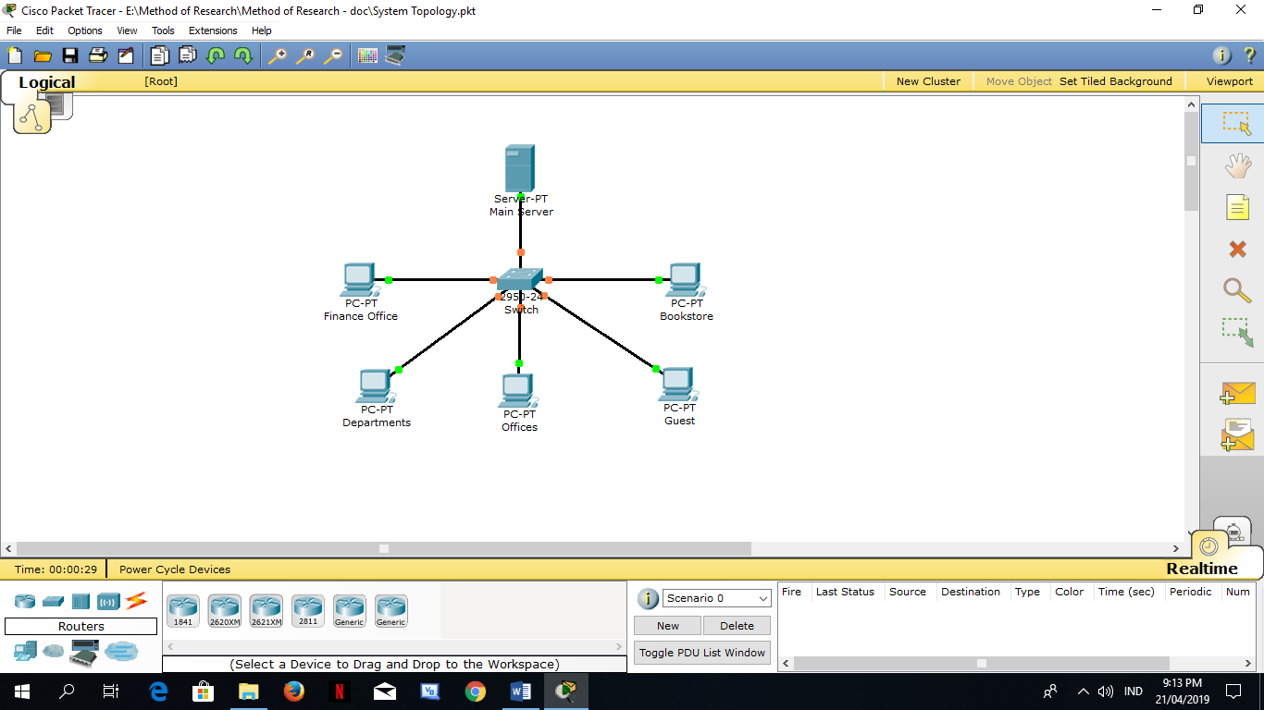

Figure 9. Network Model and Topology

This is the arrangement of the various elements involved in the networking (PC’s switch and server) of the system. Essentially, this is the topological structure of a network and may be depicted physically or logically.

Hardware and Software Requirements

This includes hardware and software applications use for the development of the system.

Hardware Requirements

* 1.6 GHz or faster processor
* 2 GB of RAM
* 5400 of RPM hard drive.
* Video card running at 1024x768 or higher display resolution
* Network Cable
* Switch
* Inkjet Printer
* Thermal Receipt Printer
* Bar Code Scanner

Software Requirement

* JavaScript

Normalize Database Modeling

Database normalization make the system easier from the user who accesses tables to the database administrator who is responsible for the overall management of every items in the database. There will be reduction in database redundancy, which simplifies data structures and save disk space. Also a normalized database is provided a security in the sense that the database administrator can grant access to limited tables to certain users. Thus, security is easier to control when there is implementation of normalization of database. To normalize database are:

1. Arrange the data into logical groupings to make it more manageable.
2. Reduce the amount of duplicate data stored in a database.
3. Organize the data in such a way that, when modify it, it makes the change in only one place.
4. Build a database wherein can manipulate the data quickly and efficiently without cooperating the reliability of the data in storage.

Testing Procedure

Testing is a procedure, which tell errors in the program. It is the major quality measure employed during software development. During testing, the program is executed with a set of test cases and the output of the program for the test cases is evaluated to determine if the program is performing as it is expected to perform. In order to make sure that the system does not have errors, the testing methods applied at different levels of software development are:

1. The system that allow accounts to be created and assign username that verify user and password.
2. The system can determine the items that need to reorder.
3. The system can eliminate and normalize the data redundancy.
4. The system developed should be test to ensure if it meets the user expectations.
5. The system can access thru network based from the SAC Bookstore to every offices.

Data Gathering Tools

All possible requirements of the system to be developed are gathered in this level. Requirements are a set of functions and limits that the user expects from the system. The researcher conducts interviews with the staff of the SAC Bookstore for data needed in analyzing the system to be developed. Also, the requirements are gathered from the users at the start of the software development phase by getting their existing files and data to be used in the development of the system. These requirements are analyzed for the strengths, and the possibility of including their requests in the system to be developed is also studied. Finally, a requirement specification document is created which serves the purpose as guidelines for the next level of the model.

Parameters to be analyzed

These are the parameters to be analyzed:

*Reorder point* in each stock balance when a new purchase order should be issued to replace inventory stock. Also, the amount of inventory to be used during the main time when stock will be replaced.

*Order quantity* is the production formula used to determine the most efficient amount of goods that should be purchased based on ordering and carrying costs.

*Inventory date* [immediately](https://www.lawinsider.com/dictionary/inventory-date)prior to the closing date.

*Receipt date* is particularly transaction was received.

*Product cost* refers to the [costs](https://www.accountingtools.com/articles/2017/5/4/cost) acquired to create a product. These include [direct materials](https://www.accountingtools.com/articles/what-are-direct-materials.html) and consumable production supplies.

*Product number* is a unique identifier, assigned to each finished/manufactured product which is ready, to be marketed or for sale.

Instrumentation

This study will gather information from SAC Bookstore though the existing file and data that are used for the transaction and inventory system. Specifically, classify and state the nature, scope and conduct of the existing system so that the researcher will have an understanding of how he is going to translate the traditional transaction system to a computerized system. Additionally, it will improve the project to make it even more useful and accessible to the community. Also, upon completing the project, the system will be subjected to testing and evaluation using instruments that will be planned by the project team in order to measure the technical performance and usefulness of the software as well as to determine its readiness for arrangement. The following instruments used are:

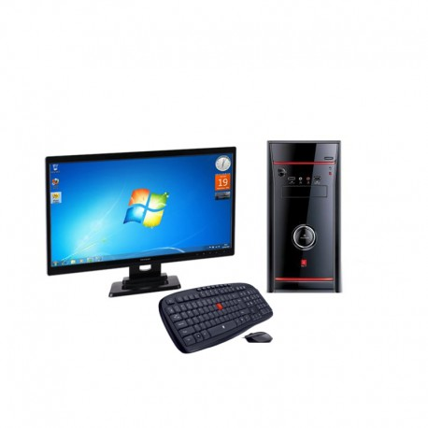

Figure 10. The Computer Systems

A computer system have a complete and functional computer including all the hardware and software requirements to make it functional for the user. It should have the ability to receive user input, process data, and with the processed data, it will create information for storage and/or output.

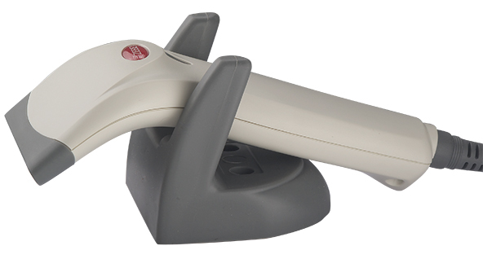

Figure 11. Bar Code Scanner

A bar code scanner device used to captures bar code of the supplies and equipments to scan in the system.

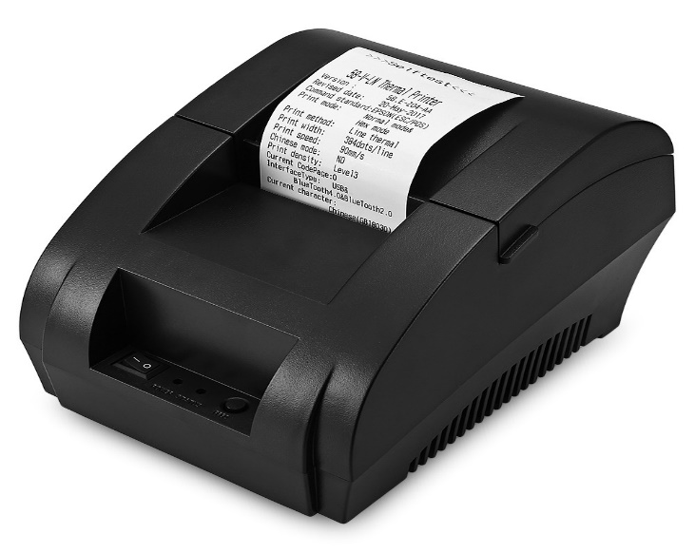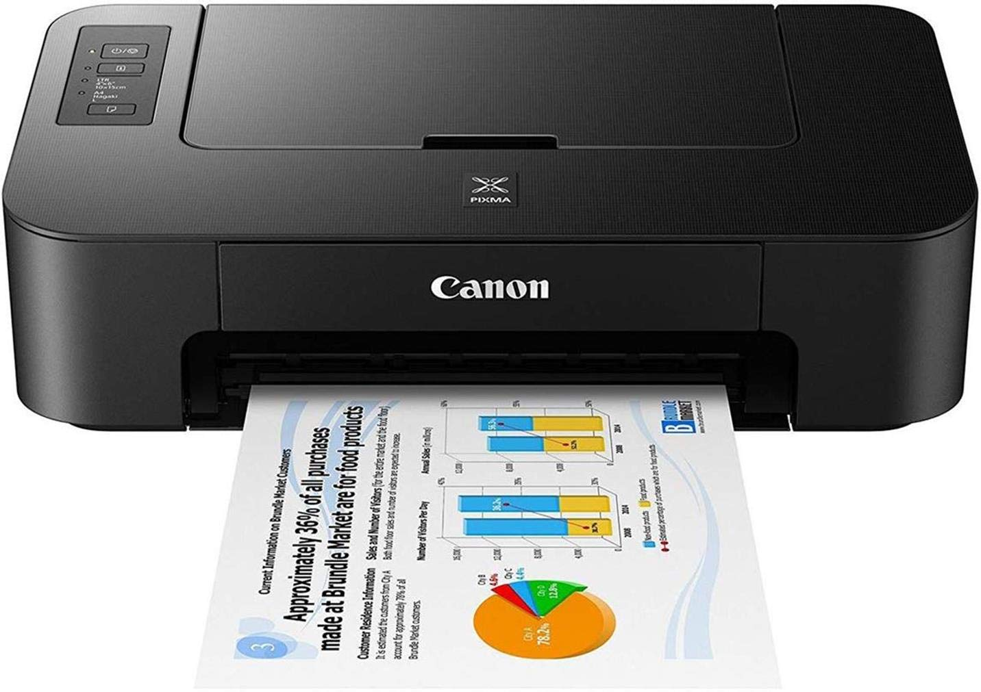

Figure 12. Printer

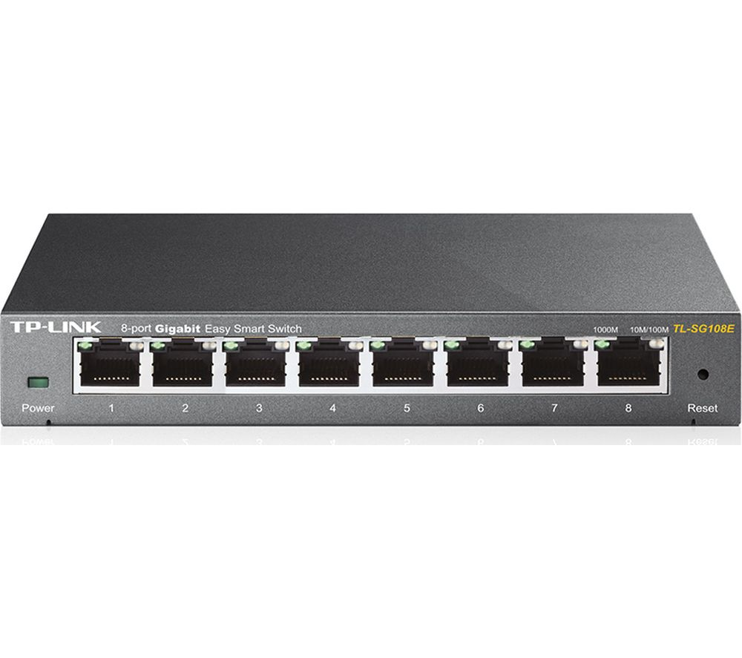 A printer used as external hardware output device that takes the electronic data stored on a computer or other device and generates a hard copy.

Figure 13. Network Switch

A network switch used to connects other devices together, then multiple data cables are plugged into a switch to support communication between different networked devices. It also manage the flow of data across a network by transmitting a received [network packet](https://en.wikipedia.org/wiki/Network_packet) only to the one or more devices for which the packet is projected. Each networked device connected to a switch that can be recognized by its [network address](https://en.wikipedia.org/wiki/Network_address), permitting the switch to direct the flow of traffic maximizing the security and efficiency of the network.

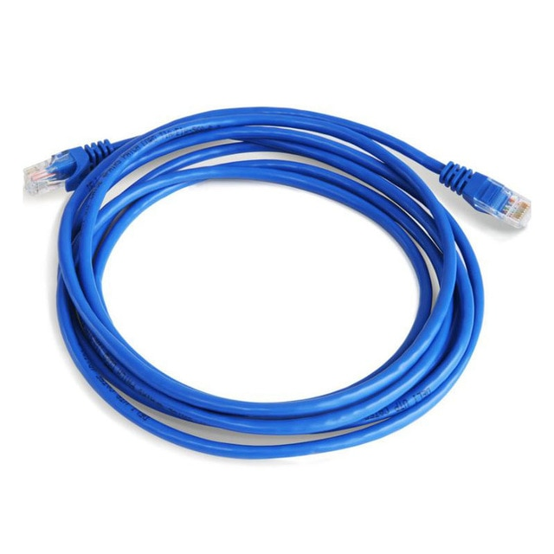

Figure 14. Network Cable

Networking cables used to connect one network device to other network devices and it can be connected two or more computers.

REFERENCES

Geoffrey T. Salvador, PECE (2016). Equipment Inventory Management and Transaction Recording Using Bar Coding Scheme via VB6*. Retrieve March 19, 2019 from https://www.ijera.com/papers/Vol6_issue6/Part%20-%203/P06060392095.pdf*

Ling Shi Cai, Leau Yu Beng, Charlie Albert Lasuin, Tan Soo Fun, Chin Pei Yee (2009). Multifunctional Barcode Inventory System for Retailing. Are You Ready for It? *Retrieved March 20, 2019 from* [*http://citeseerx.ist.psu.edu/*](http://citeseerx.ist.psu.edu/) *viewdoc/download?doi=10.1.1.192.9177& rep=rep1&type=pdf*

[Arthur J. Murphy](https://patents.google.com/?inventor=Arthur+J.+Murphy), [Joseph F. Stratton](https://patents.google.com/patent/US4554446A/en) (1985). Supermarket inventory control system and method. *Retrieved March 25, 2019 from https://patentimages.storage.googleapis.com/ cf/0c/47/75407a430546cc/US4554446.pdf*

Joseph (1999). Sales and inventory method and apparatus. *Retrieved March 25, 2019 from https://patents.google.com/patent/US5878401A/en*

[Karl L. Ginter](https://patents.google.com/?inventor=Karl+L.+Ginter), [Victor H. Shear](https://patents.google.com/?inventor=Victor+H.+Shear), [Francis J. Spahn](https://patents.google.com/patent/US6640304B2/en), [David M. Van Wie](https://patents.google.com/?inventor=David+M.+Van+Wie) (1996). Systems and methods for secure transaction management and electronic rights protection. *Retrieved March 25, 2019 from https://patents.google.com/patent/US6640304B2/en*

Joseph Brylle N. Cambronero, Nikko Andrew F. Labadan, Hyla Kay D. Labio, Ralph Jan B. Redoña and Bernil Jane F. Salarda (2013). Integrated Sales and Inventory Management System Implemented in Three-Tier Architecture. *Retrieved April 19, 2018 from https://ejournals.ph/article.php?id=6125*

Jennylen Abacahin, Delia Amil, Maricel Canda and Laurence Perocho (2012). Sales and Inventory System of Edmar Marketing. *Retreived April 19, 2018 from https://ejournals.ph/article.php?id=5528*

DLSU Engineering e-Journal. Zarina Ira V. Bernabe, Monchie C. Dela Cruz, Karen K. Jao, Jingel A. Tio and Antonio S. Gonzales Jr. (2007). Automated Inventory System Using Portable Data Acquisition Module for Bell Electronics Corporation. *Retrieved April 19, 2018 from* [*https://pdfs.semanticscholar.org/*](https://pdfs.semanticscholar.org/) *cdca/625c3326be32b5c3368692eb615e6e807138.pdf*

Bartleby Writing (2010). Online Sales Monitoring and Inventory System. *Retrieved April 19, 2018 from (Retrieved from https://www.bartleby.com/essay/Online-Sales-Monitoring-and-Inventory-System-PKC34ZA5H3GEZ)*

Spark Global Tech Systems, Inc. (2016). Sales and Inventory System. *Retrieved April 19, 2018 from http://sgtsi1.sparkglobaltech.com/sales-and-inventory-system/*

APPENDICES

APPENDIX A

Cost Analysis for SAC Bookstore Inventory System

|  |  |  |
| --- | --- | --- |
| COST | | |
| Category | Item | Amount |
| Development Cost | Bookstore Transaction and Inventory Development Team | P 20, 000.00 |
|  | Documentation | P 3, 000.00 |
|  | Miscellaneous Fees | P 2, 000.00 |
| TOTAL DEVELOPMENT COST | | P 25, 000.00 |
| TOTAL SYSTEM COST | | P 25, 000.00 |

APPENDIX B

WORK SCHEDULE

